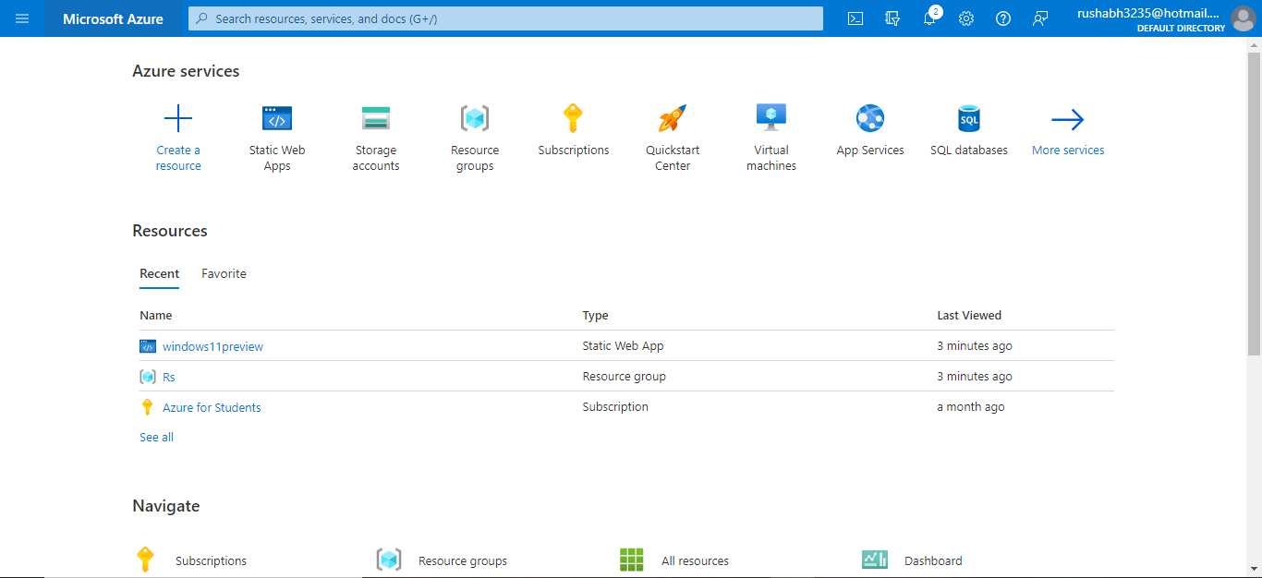

Step1: - go to azure portal.

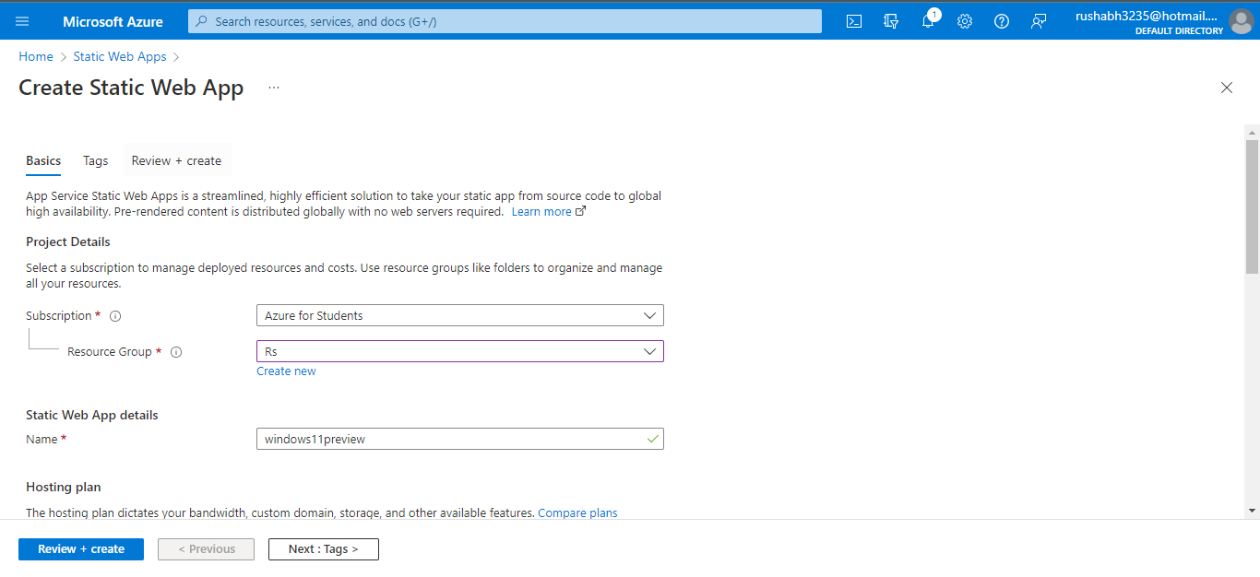

Step2: - choose your subscription and resource group and assign name of your resource.

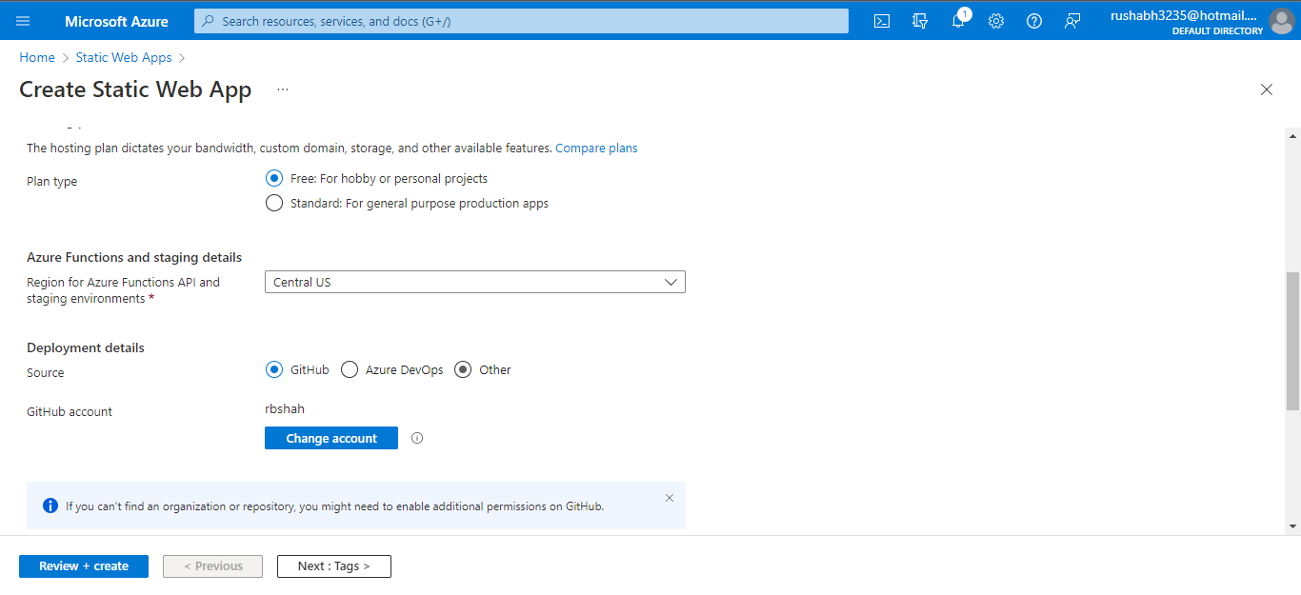step3: - choose plan and connect with GitHub account.

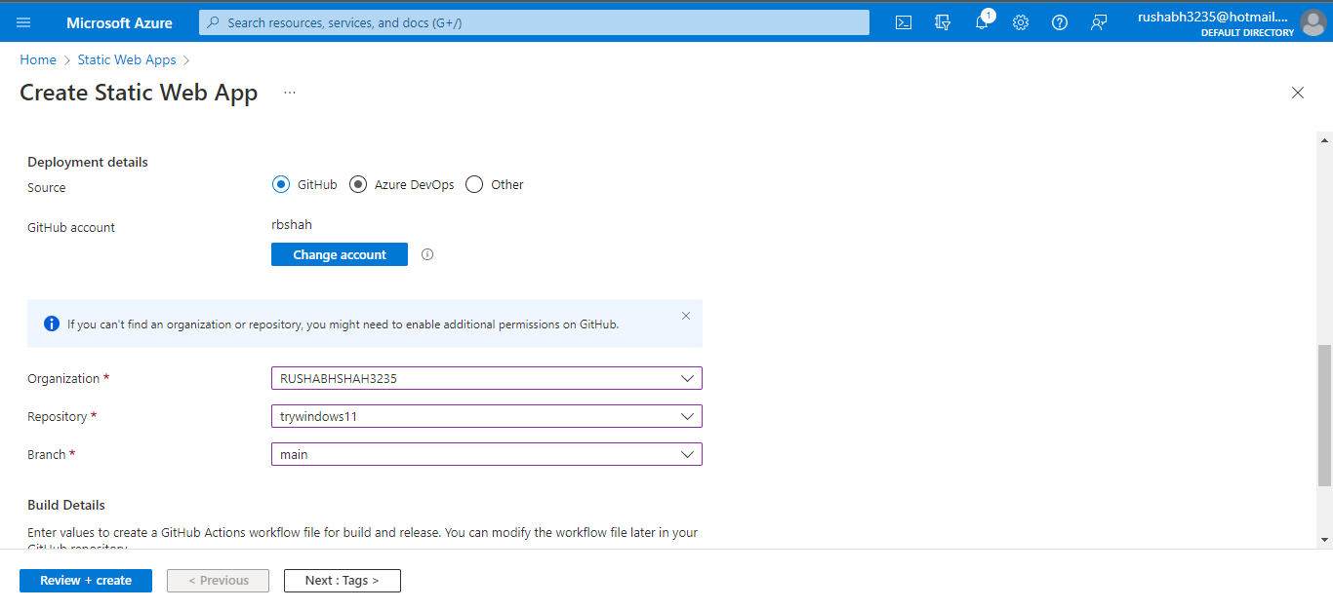

Step4: -choose organization and repo and branch and click review and create.

Step5:-now you can see project webapps hosted link:- https://black-ocean-0c080a310.1.azurestaticapps.net/